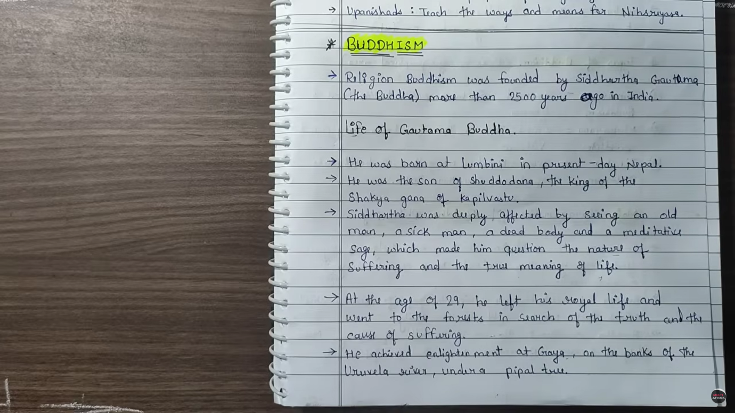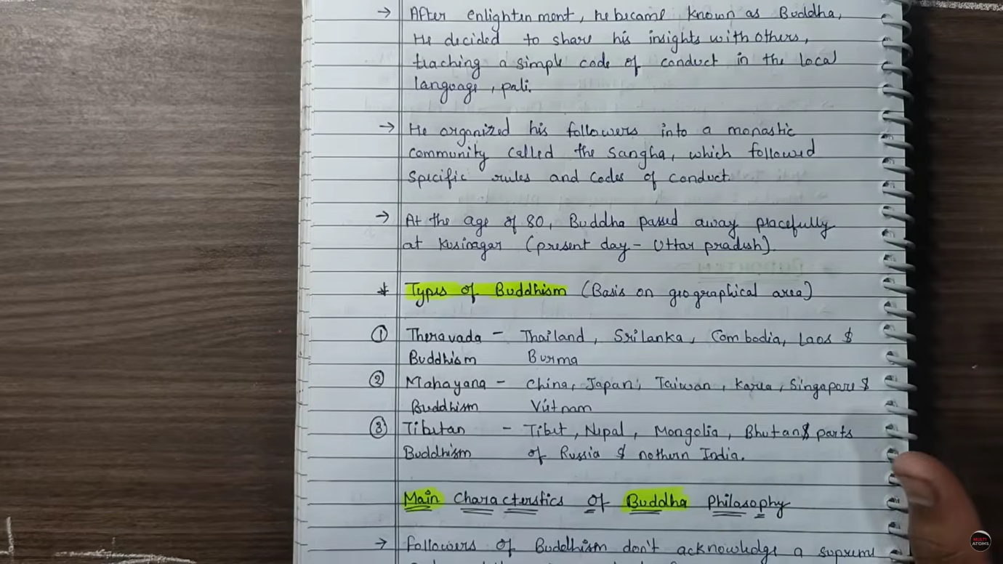

The phrase **"Namo Namo Hey Renge Kyo"** (or often chanted as **"Nam-myoho-renge-kyo"**) comes from **Nichiren Buddhism**, a branch of Mahayana Buddhism from Japan.

**Nam-myoho-renge-kyo**

* **Nam**: Devotion
* **Myoho**: Mystic law of the universe (life and death cycle)
* **Renge**: Lotus flower (symbol of cause and effect)
* **Kyo**: Sutra or teaching (the words of Buddha)

**So the whole chant means:**

“I devote myself to the Mystic Law of Cause and Effect through the Lotus Sutra.”

It’s chanted for **inner peace, clarity, and transformation**,

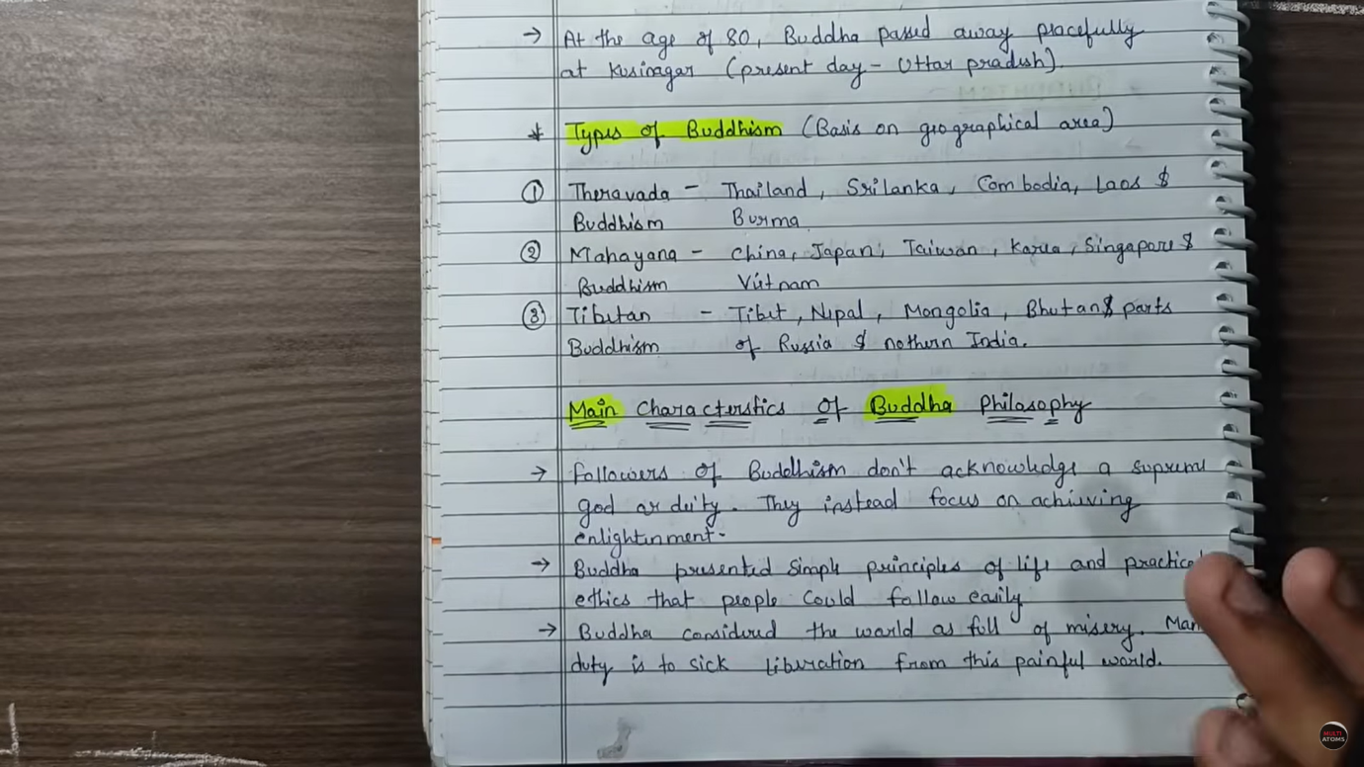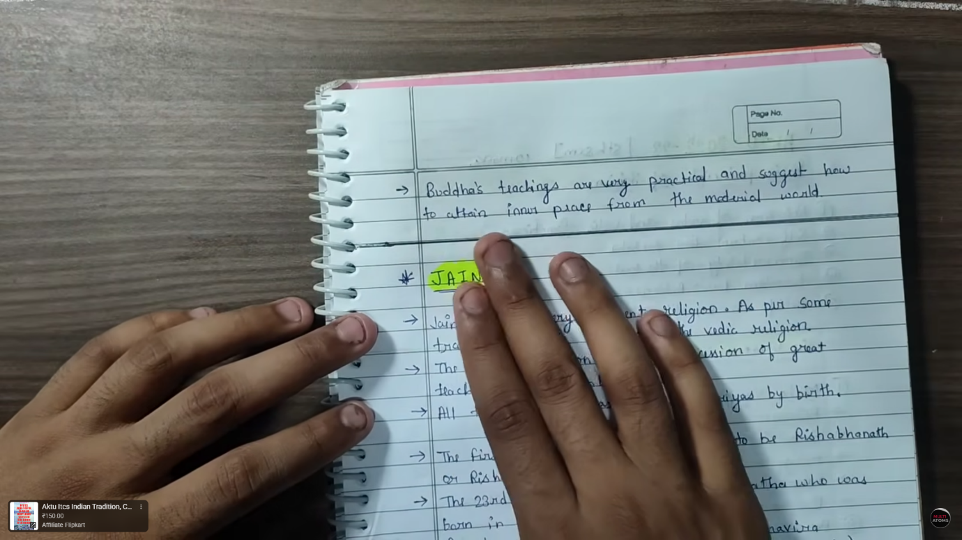

Reasons for the Decline of Buddhism in India:

**Internal Factors:**

1. **Loss of Simplicity:**
   * Original Buddhism was simple and ethical.
   * Over time, rituals and idol worship entered (especially in Mahayana Buddhism), becoming more like Hinduism.Priests and all
2. **Monastic Corruption:**
   * Many monks became disconnected from common people, living in luxury.
   * Monasteries became wealthy and corrupt, losing public respect.
3. **Language Barrier:**
   * Early Buddhism used **Pali**, understood by common people.
   * Later texts used **Sanskrit**, making it less accessible to the masses.
4. **Sectarian Divisions:**
   * Splitting into **Hinayana**, **Mahayana**, **Vajrayana** weakened unity and confused followers.

**External Factors:**

1. **Revival of Hinduism:**
   * Thinkers like **Shankaracharya**, **Ramanuja**, and the **Bhakti movement** revitalized Hinduism with personal devotion, making it more attractive.

**Royal Patronage Decline:**

* Gupta rulers and later kings favored Hinduism.
* Lack of state support weakened Buddhist institutions.

**Muslim Invasions:**

* + Invaders like **Bakhtiyar Khilji** destroyed key Buddhist centers (e.g., **Nalanda**, **Vikramashila**).
  + Monks fled to Tibet and Nepal.